It is heartly dedicated to our beloved parents, without their support and guidance we would not be able to finish our project well in time. They sacrificed their today for our better tomorrow.

CONTENTS

- Preface

- Acknowledgement

- Synopsis

- Introduction

- Software Development Layers

- Hardware & Software Requirements

- Running the project

- Feasibility study

- Objectives

- ER-Diagram & DFD’s

- Data Structure tables

- Forms

- Reports

- Form details

- Conclusion

- Bibliography

- Cost Estimation of the project

- Gantt Chart

PREFACE

Mankind is a threshold of a new revolution brought about by the advent of the information technology (I.T). A computer is an externally powerful tool for performing in the area of computational speed and accuracy.

As the computer market increases the software market becomes more competitive. We intend to make entry into every expanding field of software development.

The main motivation behind the computerization in its high speed of computation is greater accuracy and security of information through back files.

Keeping this in mind we aimed to develop a software package for Dr. V. P. Hegdekatti on management system of financial investment. We have tried to replace existing manual system by computerized system in order to provide better service and easy maintain.

The reports include the documentation on visual studio, database management of design and specification requirements and so on.

We do not claim that our work is great success. We have tried our level best to make it simple and efficient. Our software package is menu driven so little computer knowledge is sufficient to use this software.

ACKNOWLEDGEMENT

We the students of final year diploma in Computer Science & Engineering of Govt. Polytechnic Karwar avail this opportunity to express our heartfelt gratitude to our lecturers, principal and all those people who were supportive enough to guide us throughout the completion of the project.

We owe our sincere thanks to our Head of the Department Smt. Rekha Naik B.E(Computer Science) for her esteem corporation in successful completion of the project.

We express our sincere gratitude to our guide Smt. Varsha Phayade B.E.(Electronics and Telecommunication) lecturer, for her guidance and support, in making the project execute at its best.

We specially thank Shri Narayan Bhat(prop: Chaitra Software) our tuition sir for his unconditional support in every step and making the project a success.

We also thank Shri V. M. Hegde, Principal of Govt. Polytechnic Karwar for providing us a platform to do this project.

SYNOPSIS

Name of the project : Financial and Investment Management System

Aim of the project : To develop financial and investment software for a
Self- employed professional

Utilities : Visual Basic Studio 2008
SQL Server 2005

Operating System : Windows 2000/xp or higher version

Submitted by : Balachandra Hegde

Priyanka Samal

Reshma Naik

Radhalaxmi M

Divya Kodiya

Vittal Desai

Sachin Huluswar

INTRODUCTION

The project titled Financial and Investment software for a self employed professional is to develop an application software for implementing the investment and financial transaction for the professionals. The various type of professional like docters / engineers or other technical or non-technical professionals.

It is observed that many such are investing the finance in various schemes and financial growth or insurance sectors.

To keep track of such investments and periodic remainders for periodic payments or receivables, manual observations are time consuming and results in penalty payments.

To overcome such problems there is no such software available in general and most of the people depend on diary entries. Hence this project is useful for such professionals.

SOFTWARE DEVELOPMENT LAYERS

Software is a collection of computer programs written by programmers and executed on the computer which provides desired function and performance.
The various layers are:
- Requirement Analysis
- Software Design
- Coding
- Testing
- Maintenance

Requirement Analysis:

It is the identification of what is needed from the system but not how the system will achieve its goal. It is done to understand the problem. Software requirement specification document is produced.

There are two major activities in this phase:
- Problem Understanding: involves the process of understanding the problem and its contents. It also concentrates on understanding the existing system and the inputs and outputs.
- Requirement specification: Here requirements must be specified in the form of requirement specification document.
This document includes:
- All the functional & performance requirements
- Formats of inputs & outputs
- All factors that effect the design

Software Design:

This is the solution domain i.e. from “what is needed” to “how to satisfy the need”. This phase has two separate sub phases.
- System design
- Detailed design

Coding:

Coding phase translates the design of the system into code in given programming language. The coding should focus on developing program i.e. easy to read and understand.

Testing:

This is the major quality control measure used during software development. The basic function of this phase is detection of errors in the program.

Maintenance:

Once the software is developed and is delivered, it enters the maintenance phase. All systems need maintenance periodicity to backup the data which is the back end of SQL Server. Although the front end maintenance is only for the modification required in the future may need developer activity. The regular back end maintenance should be thought to administrator for periodic backup..

HARDWARE & SOFTWARE REQUIREMENTS

Hardware Requirements:

Processor : Pentium 4,1.8 Ghz or higher

Memory : RAM-512 MB/1 GB or higher

Hard disk space : 80 GB or higher

Software Requirements:

Operating System : Win-2000/xp or higher version

Front end : Visual Studio 2008

Back end : SQL Server 2005

Drivers :

We are doing this project for or client!
Name: Dr. V. P. Hegdekatti
Address: Muralidhar math road,
Karwar

FEASIBILITY STUDY

- ECONOMIC FEASIBILITY :

This project is financially feasible. The development cost is negligible as hardware and software requirements are easily available. Implementation of this software does not require much expense for its installation and maintenance.
Since software is developed using SQL Server as back end, amount incurred will be very less compared to other back end softwares like oracle. Compared to the earlier cost of the task completion, computerization reduces the overall cost of the task to some extent.

- TECHNICAL FEASIBILITY :

The project undertaken is technically feasible and is within the state of art. Softwares like VB.NET(front end) and SQL Server 2005(back end) are used to meet software requirements.
Any computer with minimum configuration of 80 GB HDD, 512 MB RAM can easily install this software package and use it without any additional expense. The software developed can be implemented in all the machines with an existing server.

- OPERATIONAL FEASIBILITY :

Since the software is developed on click and execute basis, any user can comfortably work with this project. Computerization of the system will remarkably extend the computational speed, reliability and accuracy of transactions.
This project is user friendly, easy to handle and quick to operate. With demonstration, any normal computer user can easily work on this package without any additional training.

Installing and Running our software

- Attach the database, copy the database files to target computer D drive. Then open SQL Server Management Studio right click on database > select attach > browse the mdf file then click on ‘OK’.

- Copy the crystal report files to D drive project folder. Run the setup program from the CD. Then click on ‘Install’. Then run the program from Start > Program > Fms

OBJECTIVES

- The main objective is to develop software to withstand the problems faced due to the existing manual system.

- To enter and maintain the mutual fund investments.

- To enter and maintain the postal investments.

- To maintain and observe the LIC investments.

- To maintain and observe the private insurance.

- To observe the status of fixed deposits and its status.

- Bank account credit and debit entries.

- Shares details.

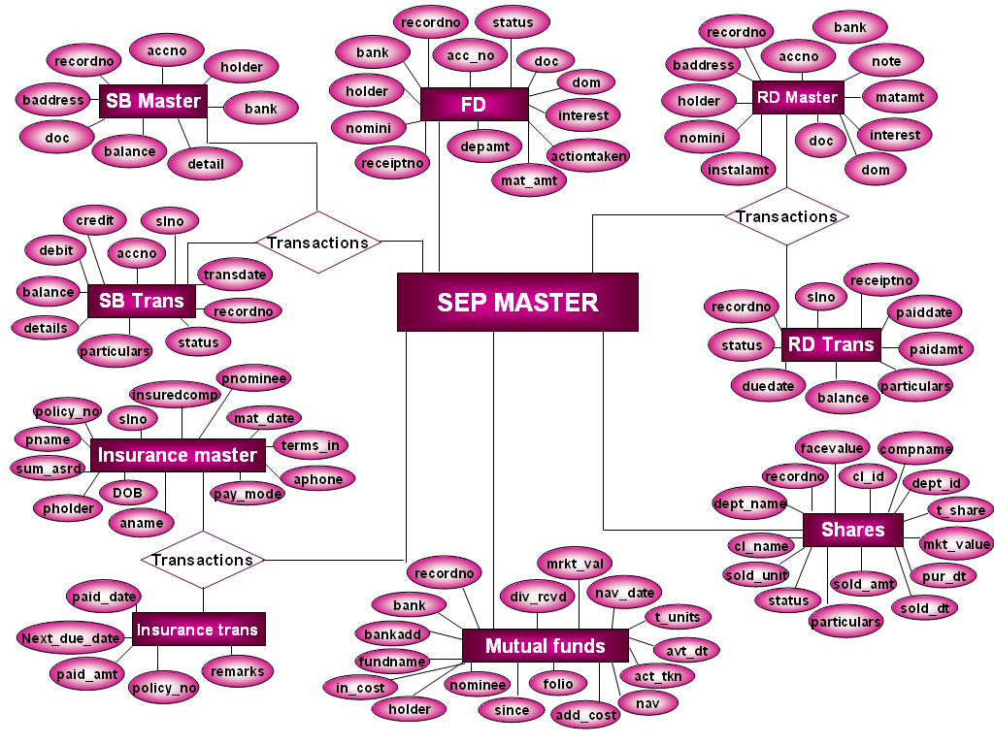

TABLES

Login

FIELD NAME | DATATYPE | SIZE | DESCRIPTION
userid | nvarchar | 50 | User id
password | nvarchar | 50 | Password

Saving Bank account
Table name: sbmaster

FIELD NAME | DATATYPE | SIZE | DESCRIPTION
recordno | int |  | Record number
accno | nvarchar | 50 | Account number
holder | nvarchar | 50 | Holder name
bank | nvarchar | 50 | Bank name
baddress | nvarchar | 50 | Bank address
doc | datetime | 8 | Datetime picke
balance | numeric | 18,0 | Balance
details | nvarchar | 50 | Detais

Table name: strans

FIELD NAME | DATATYPE | SIZE | DESCRIPTION
slno | int |  | Serial number
accno | nvarchar | 50 | Account number
trandate | datetime | 8 | Transaction date
credit | numeric | 18,0 | Credit amount
debit | numeric | 18,0 | Debit amount
balance | numeric | 18,0 | Balance amount
details | nvarchar | 50 | Details
particulars | nvarchar | 50 | Particulars
status | char | 10 | Status
recordno | int |  | Record number

Table name: sbtmp

FIELD NAME | DATATYPE | SIZE | DESCRIPTION
slno | int |  | Serial number
accno | nvarchar | 50 | Account number
trandate | datetime | 8 | Transaction date
credit | numeric | 18,0 | Credit amount
debit | numeric | 18,0 | Debit amount
balance | numeric | 18,0 | Balance
details | nvarchar | 50 | Details
particulars | nvarchar | 50 | particulars

Fixed Deposit
Table name: fd

FIELD NAME | DATATYPE | SIZE | DESCRIPTION
recordno | numeric | 18,0 | Record number
acc_no | nvarchar | 50 | Account number
bank | nvarchar | 50 | Bank name
holder | nvarchar | 50 | Holder name
nomini | nvarchar | 50 | Nominee name
doc | datetime | 8 | Date of Commencement
dom | datetime | 8 | Date of Maturity
date | datetime | 8 | Date
receiptno | nvarchar | 50 | Receipt number
depamt | numeric | 18,0 | Deposit amount
mat_amt | float |  | Maturity amount
interest | float |  | Interest
actiontaken | nvarchar | 50 | Maturity action
status | char | 10 | Status

Table name: fd_tmp

FIELD NAME | DATATYPE | SIZE | DESCRIPTION
recordno | numeric | 18,0 | Record number
acc_no | nvarchar | 50 | Account number
bank | nvarchar | 50 | Bank name
holder | nvarchar | 50 | Holder name
nomini | nvarchar | 50 | Nominee name
doc | datetime | 8 | Date of Commencement
dom | datetime | 8 | Date of Maturity
date | datetime | 8 | Date
receiptno | nvarchar | 50 | Receipt number
depamt | numeric | 18,0 | Deposit amount
mat_amt | float |  | Maturity amount
interest | float |  | Interest
actiontaken | nvarchar | 50 | Maturity action
status | char | 10 | Status

Insurance
Table name: insurance

FIELD NAME | DATATYPE | SIZE | DESCRIPTION
slno | numeric | 18,0 | Serial number
Insured_comp | varchar | 50 | Insured company
policy_no | nvarchar | 50 | Policy number
pname | varchar | 50 | Policy name
sum_assured | numeric | 18,0 | Assured sum
pholder | varchar | 50 | Policy holder
pnominee | varchar | 50 | Policy nominee
DOB | datetime | 8
mat_date | datetime | 8 | Maturity date
terms_in | numeric | 18,0
pay_mode | varchar | 50 | Pay mode
agent_name | varchar | 50 | Agent name
agent_phone | numeric | 18,0 | Agent phone number

Table name: insurance_tmp

FIELD NAME | DATATYPE | SIZE | DESCRIPTION
slno | numeric | 18,0 | Serial number
Insured_comp | varchar | 50 | Insured company
policy_no | nvarchar | 50 | Policy number
pname | varchar | 50 | Policy name
sum_assured | numeric | 18,0 | Assured sum
pholder | varchar | 50 | Policy holder
pnominee | varchar | 50 | Policy nominee
DOB | datetime | 8
mat_date | datetime | 8 | Maturity date
terms_in | numeric | 18,0
pay_mode | varchar | 50 | Pay mode
agent_name | varchar | 50 | Agent name
agent_phone | numeric | 18,0 | Agent ph_number
next_due_date | datetime | 8 | Due date

Table name: instrans

FIELD NAME | DATATYPE | SIZE | DESCRIPTION
paid_date | datetime | 8 | Paid date
paid_amt | numeric | 18,0 | Amount paid
next_due_date | datetime | 8 | Due date
remarks | nvarchar | 50 | Remarks
policy_no | nvarchar | 50 | Policy number

Table name: instmp

FIELD NAME | DATATYPE | SIZE | DESCRIPTION
paid_date | datetime | 8 | Paid date
paid_amt | numeric | 18,0 | Amount paid
next_due_date | datetime | 8 | Due date
remarks | nvarchar | 50 | Remarks
policy_no | nvarchar | 50 | Policy number

Mutual fund
Table name: mutualfund

FIELD NAME | DATATYPE | SIZE | DESCRIPTION
recordno | numeric | 18,0 | Record number
bank | nvarchar | 50 | Bank name
bankadd | nvarchar | 50 | Bank address
fundname | nvarchar | 50 | Fund name
holder | nvarchar | 50 | Holder name
nominee | varchar | 50 | Nominee name
folio | numeric | 18,0
since | datetime | 8
t_units | numeric | 18,0 | Total units
in_cost | numeric | 18,0 | Initial cost
add_cost | numeric | 18,0 | Additional cost
nav | numeric | 18,0 | Net Asset Value
nav_dt | datetime | 8 | Nav date
market_val | numeric | 18,0 | Market value
div_rcvd | float | 18,0 | Dividend received
act_tkn | nvarchar | 50 | Action taken
act_dt | datetime | 8 | Action date

Shares
Table name: shares

FIELD NAME | DATATYPE | SIZE | DESCRIPTION
recordno | numeric | 18,0 | Record number
comp_name | nvarchar | 50 | Company name
dept_name | nvarchar | 50 | Department name
cl_name | nvarchar | 50 | Client name
dept_id | nvarchar | 50 | Department id
cl_id | nvarchar | 50 | Client id
t_share | numeric | 18,0 | Total shares
facevalue | float |  | Face value
mkt_value | float |  | Market value
pur_dt | datetime | 8 | Purchase date
sold_dt | datetime | 8 | Sold date
sold_unit | numeric | 18,0 | Sold unit
sold_amt | float |  | Sold amount
status | nvarchar | 50 | status
particulars | nvarchar | 50 | particulars

Form details

Login form:

It is used to authenticate identity of the user whether he is a valid user or not by requesting the user to enter user name and password. If the given details are valid, then the user gains access to the main module or else the user’s request for access will be rejected.

MDI FORM:

This is the major form that allows us to view various forms. An MDI application contains multiple data windows. You can switch between windows by clicking the desired window with the mouse or by selecting choices from the Window menu.

Our software program has menus such as Bank accounts, Stock, Policy and Manage which inturn have sub menu within them.
- Click on the main menu and select the required sub menu.

Savings Bank Account:

Allows us to enter new account details & view the existing ones
- Click on ‘New account’ to add new account details & then click ‘Save account’ to save it.
- Click on ‘New’ for entering new transaction details and then save it.
- Click on find to search a particular account based on transactions.
- Update allows updating a particular transaction details.
- Deletion is possible by clicking on ‘Delete account’ to delete a particular account details and ‘Delete’ for transaction details.
- Close button closes the form.
- Clear button clears all the fields.

Fixed Deposits:

Allows us to enter and view various FD details
- Click on ‘New’ to add new details and then save it.
- Click ‘Find’ for searching specific FD details.
- Delete allows deleting a particular fixed deposit record.
- Update allows for updating the altered details.
- Click on ‘View’ to display all the records at ones.
- Click on ‘Alert’ to get a report for specific FD record that has reached its nearest maturity date.
- ‘Save to Archive’ button is used to shift a particular record to the archive whose present status is closed.
- Close button closes the form.

Recurring Deposit:

Allows us to enter and view various RD details
1) Click on ‘New Acc’ to enter new account details and save it by
clicking ‘Save Acc’.
2) Click on ‘Delete Acc’ to delete particular RD details.
3) To insert a new transaction details click ‘New trans’ and then save it.
4) ‘Find’ is used to search a particular record and any changes done can
be saved using ‘Update’ button.
5) Click on ‘Delete’ to delete a record.
6) Click on ‘Alert’ to view a specific record that has reached its nearest
maturity

Mutual funds:

Allows us to enter details of various funds and view them
1) ‘New’ enables us to enter new mutual fund details .
2) Search allows to search for previously placed orders.
3) Delete allows to delete a particular record.
4) Close button closes the form.
CONCLUSION

This project is designed in such a way that fulfils the requirement of port. We could not develop actual shipping, unloading and export system instead we try to develop the system of as unloading management system.

Our main aim of computerization is better speed, accuracy and avoiding manual errors. We do not know, up to what extend we have been successful in our attempt. This can further be modified to get more powerful system.

We are very thankful to our parents, Smt. Rekha Naik (HOD of cs department), Smt. Varsha Phyade (Staff in charge), Shri. Narayan Bhat and our beloved principal Shri. V. M. Hegde.

THANK YOU,

PROJECT TEAM.

CONCLUSION

Our project is developed for our client Dr. V. P. Hegdekatti. This project is designed in such a way that it fulfils the requirements of our client. We don’t know how far we are succeeded in developing the project but we have tried our level best. We have sincerely tried to give them good software which will be very useful for them. Our project can be further developed to improve it and still make it better.
We have made a small effort to improve and develop their present working situation.
Hope this software is used by al the professionals who are managing such financial investment in the district and tries to get their work done easier, faster and more accurately.

GANNT CHART

Following Chart represents the Activities that will be taken place on a weekly basis.

Project Phase | Week  1,2,&3 | Week  4,5,6 &7 | Week  8,9,10 | Week  11,12,  13,14,  15 | Week  16,17 &18 | Week  19,20 | Week  21,22 | Week  23
Requirement Specification | X
System Design  Phase |  | X
Development Phase |  | X | X |  | X | X |  | X
QA Testing |  |  |  | X |  | X | X | X
Implementation &  Feedback gathering |  |  |  |  |  |  | X
Final Implementation |  |  |  |  |  | X | X
Documentation |  |  |  |  |  |  | X | X

COST ESTIMATION OF THE PROJECT

Project Phase | Project Analysis | Development | QA Analysis | Report  Formulation

Requirements Analysis (in man days) | 10
System Design Phase (in man days) |  | 8
Development Phase (in man days) |  | 25
Documentation (in man days) |  |  |  | 10
Testing (in man days)/debug |  |  | 4
Implementation/ Maintenance |  | 10
TOTAL Man Days |  |  |  | 67

Total Estimate for Phase I of the Project Rs 25,000/-

